- Created a linked service to connect to ADLS Gen2 using Account Key Method.
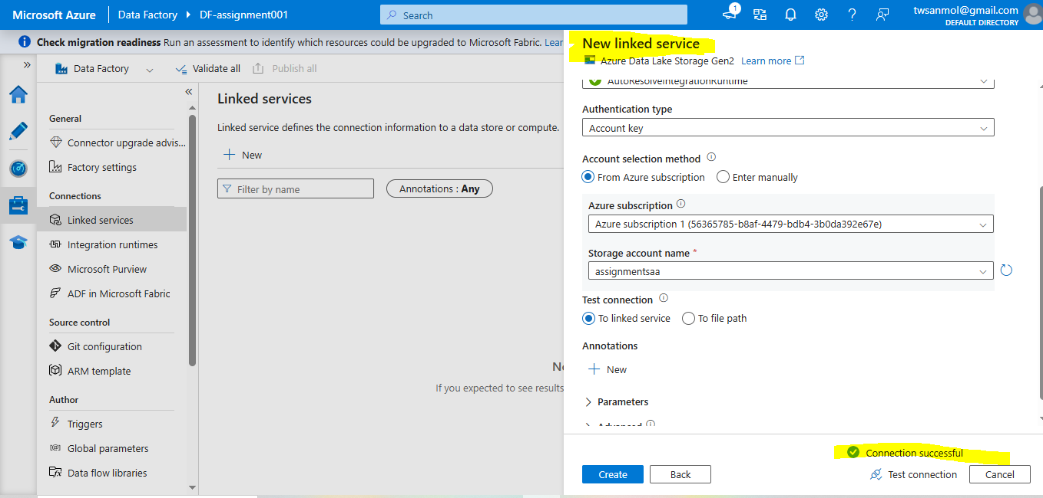
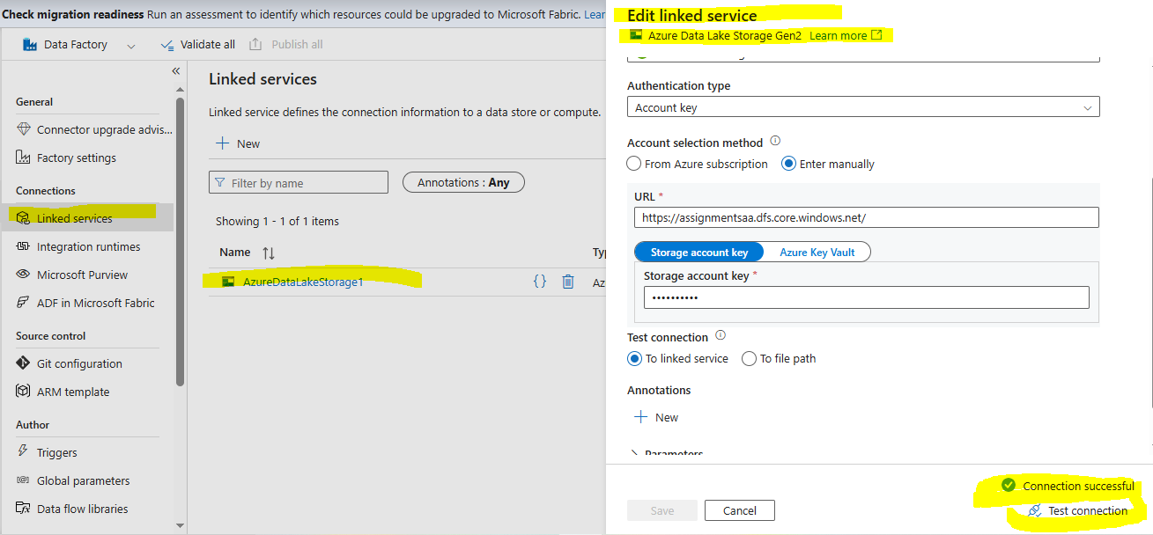

- Created a linked service to connect to ADLS Gen2 using SAS Token URL.
SAS URL- (https://assignmentsaa.dfs.core.windows.net)
SAS token – (sv=2024-11-04&ss=bfqt&srt=sco&sp=rwdlacupyx&se=2026-01-12T22:18:58Z&st=2026-01-12T14:03:58Z&spr=https&sig=rSomhh7E%2BnXk1VFJ5ujCIx6rCuWkW3tiklTY%2Br42OH8%3D)
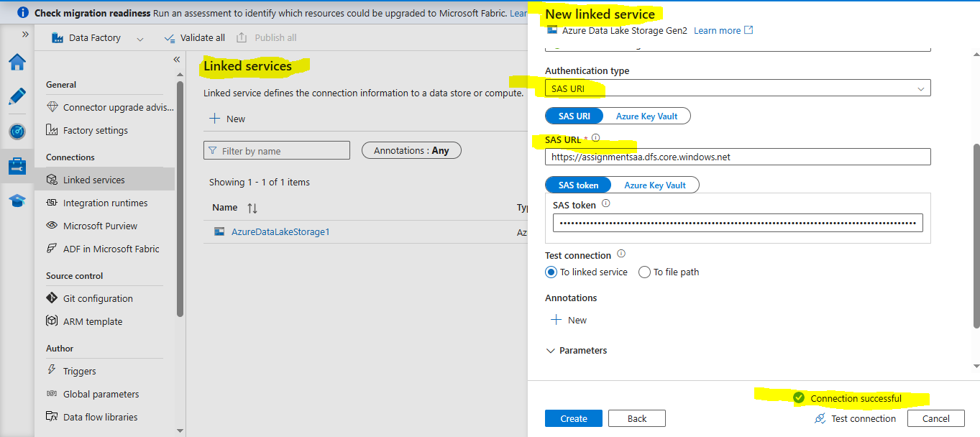

- Created a linked service to connect to Azure SQL DB using SQL Authentication Method.
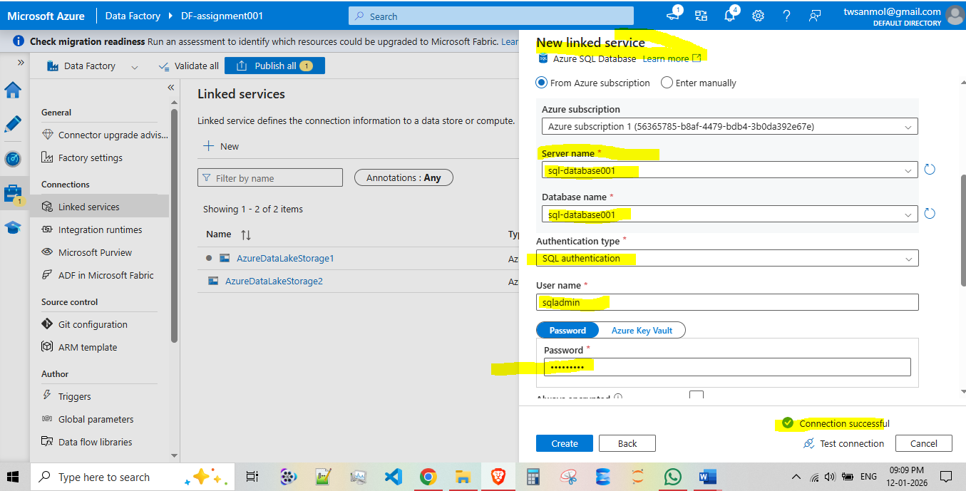

- Create a linked service to connect to Azure Synapse Analytics using SQL Authentication Method.
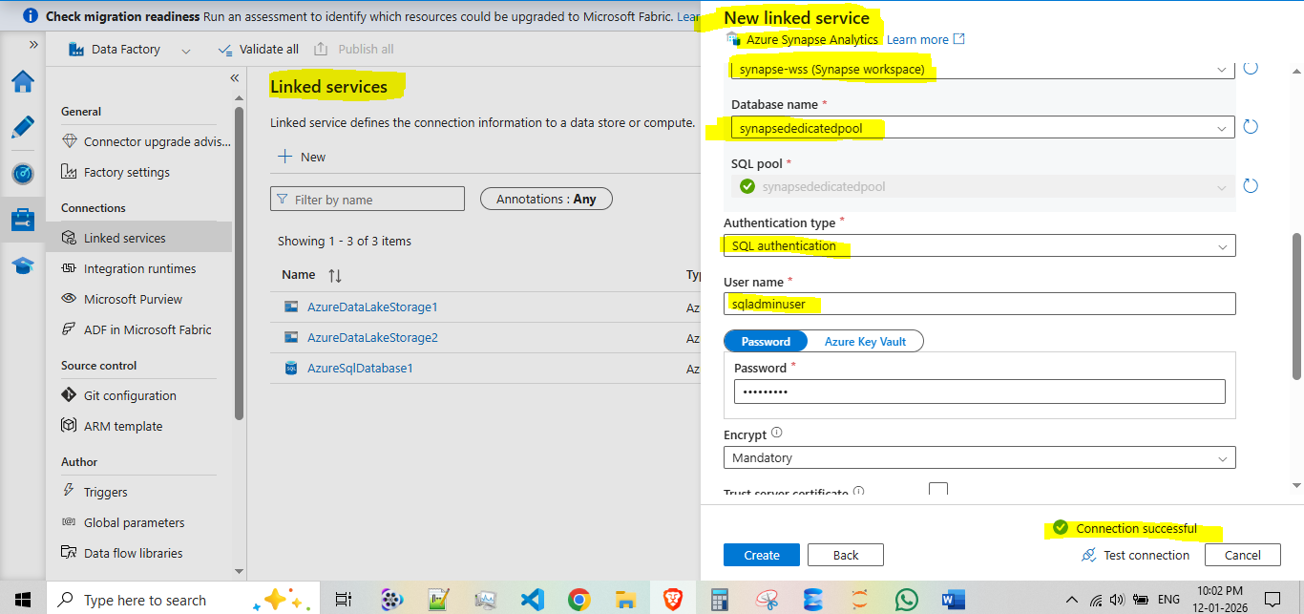

- Created database in serverlesspool and created master key password for better encryption.
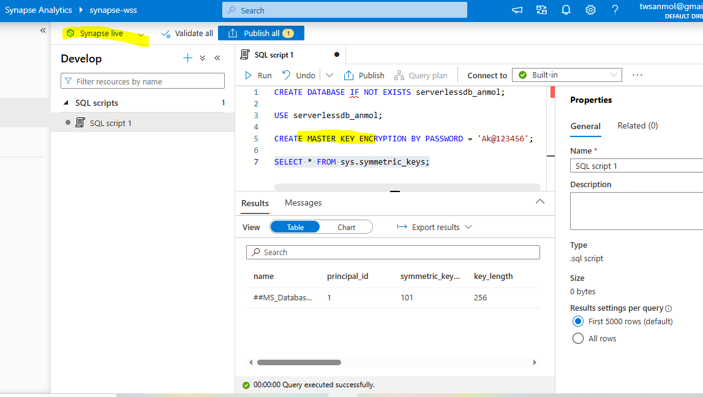

- created a container “externaldatasource” and directory “inputdata” in it. Upload the files from DataSources folder to this directory.
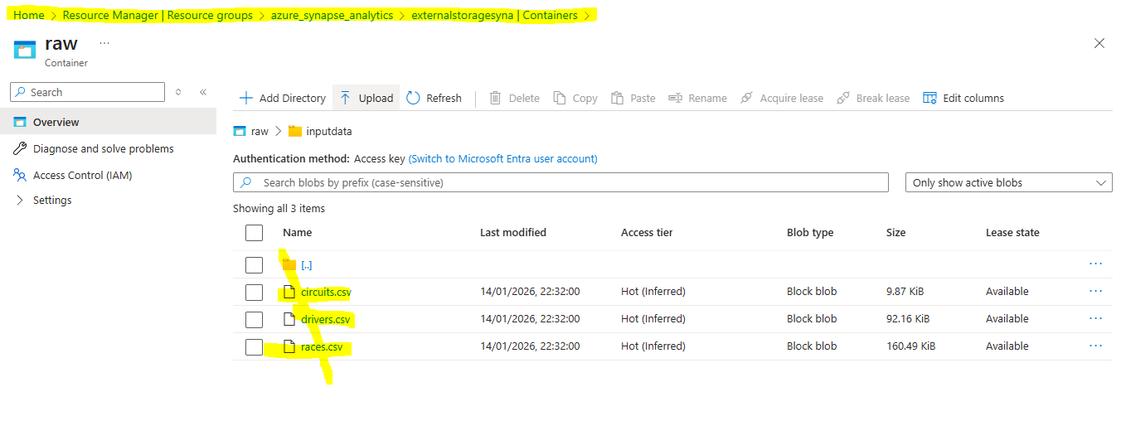
- Created an external data source pointing to this location.

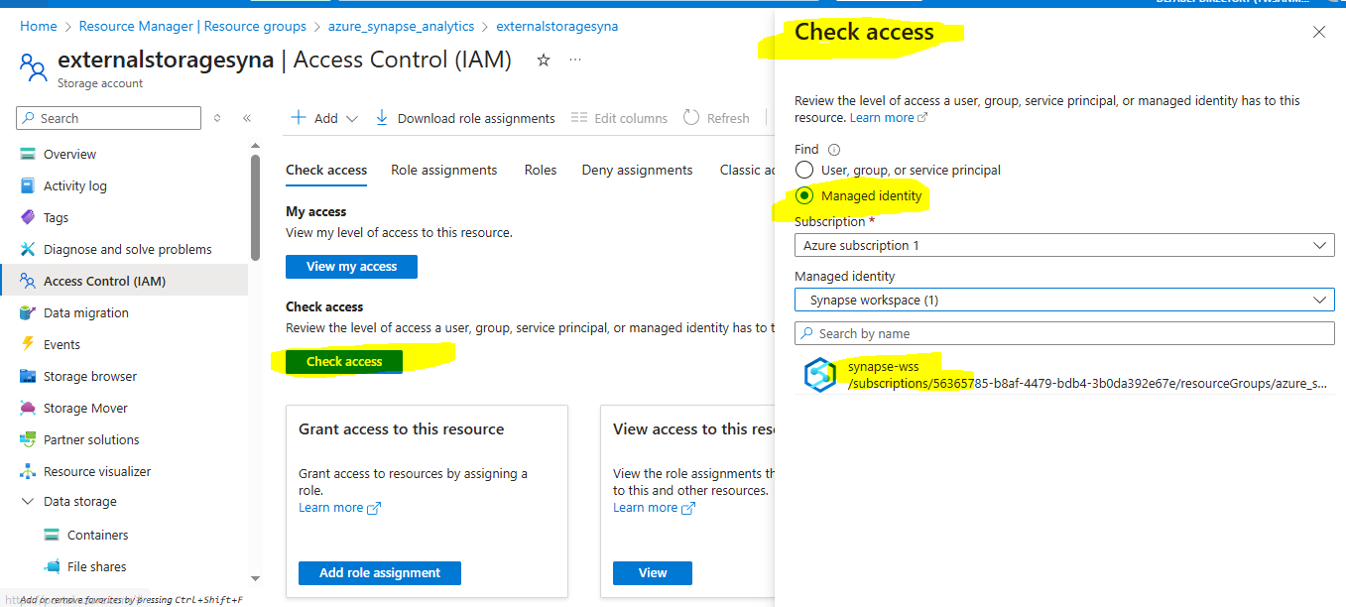

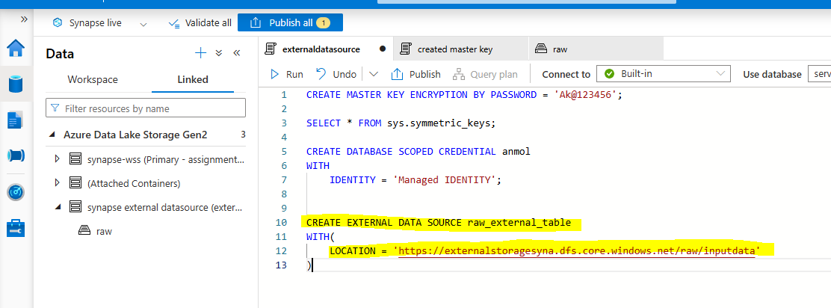

- Access a external file format as an needed csv, parquet etc.
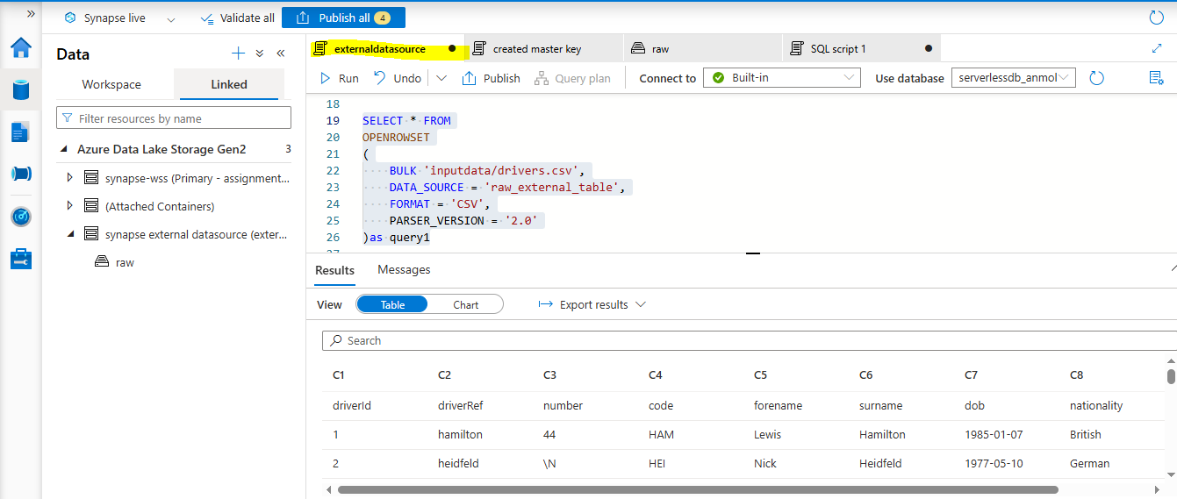

- Created an external table using create external table statement using Electric_Vehicle_Population_Data_1.csv.
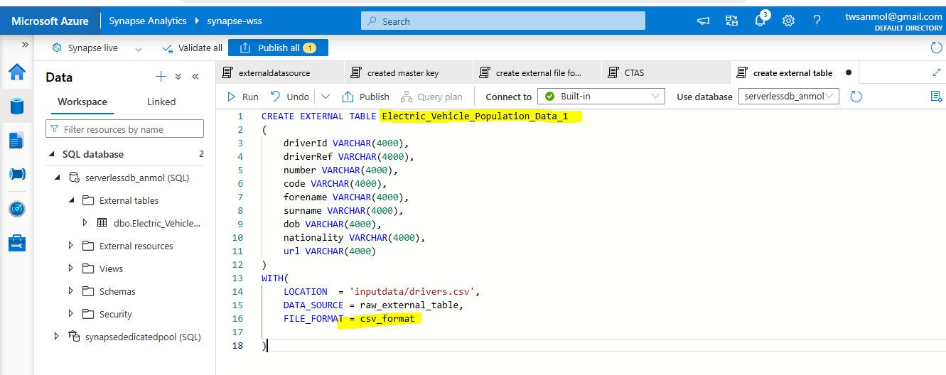

- Create an external table using create external table statement using covid_tracking.parquet file.
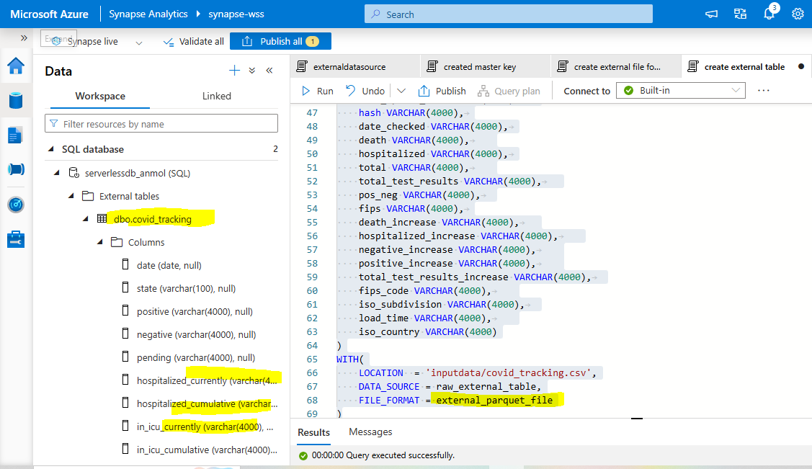
- Read and Generate a select statement using synapse UI to read data from csv and parquet file
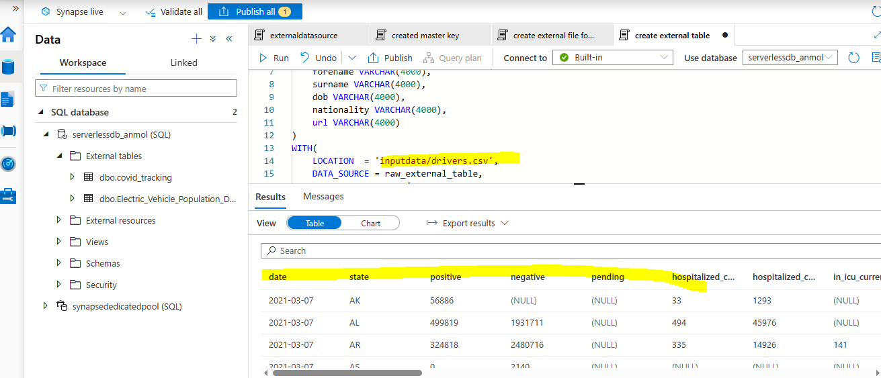
- Create an external table using create external table as select (CETAS) statement using Electric_Vehicle_Population_Data_1.csv file
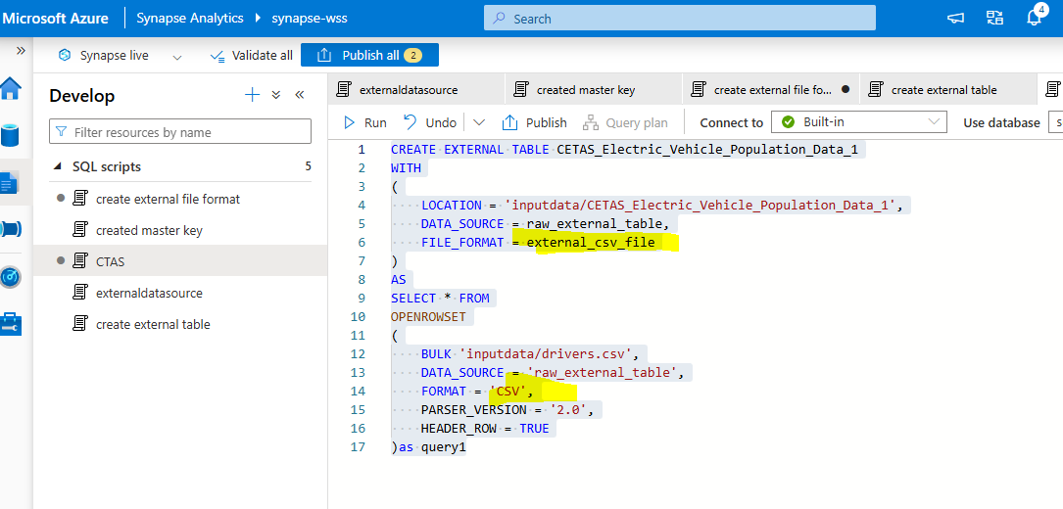
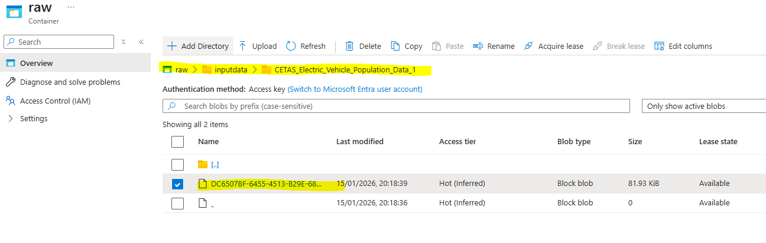
- Create an external table using create external table as select (CETAS) statement using covid_tracking.parquet file
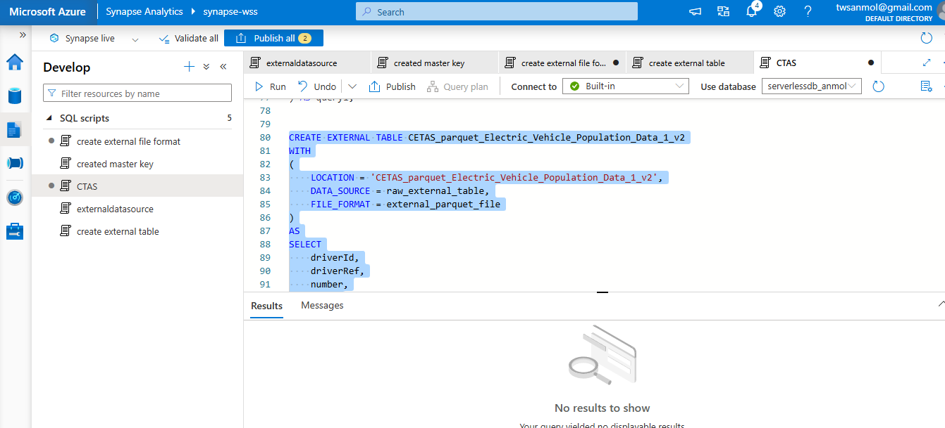
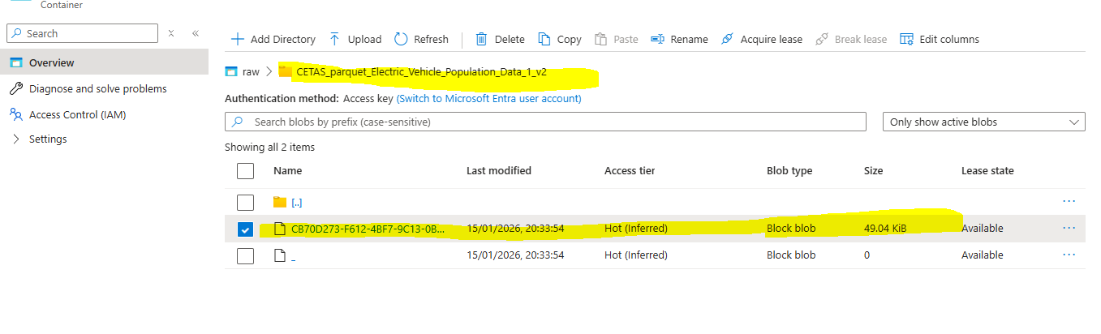
- Create view on each external table

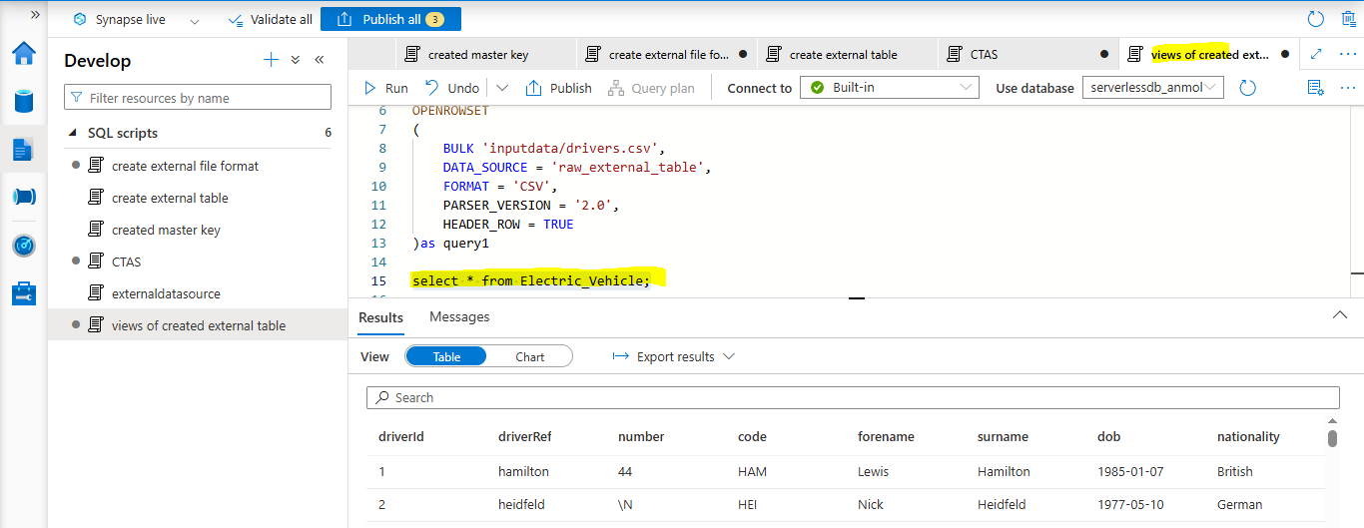

AZURE DATA FACTORY

- In Azure Data Factory, create a pipeline to copy data from “SalesLT.Address” Table to “retail.Address” table in same Azure SQL DB.
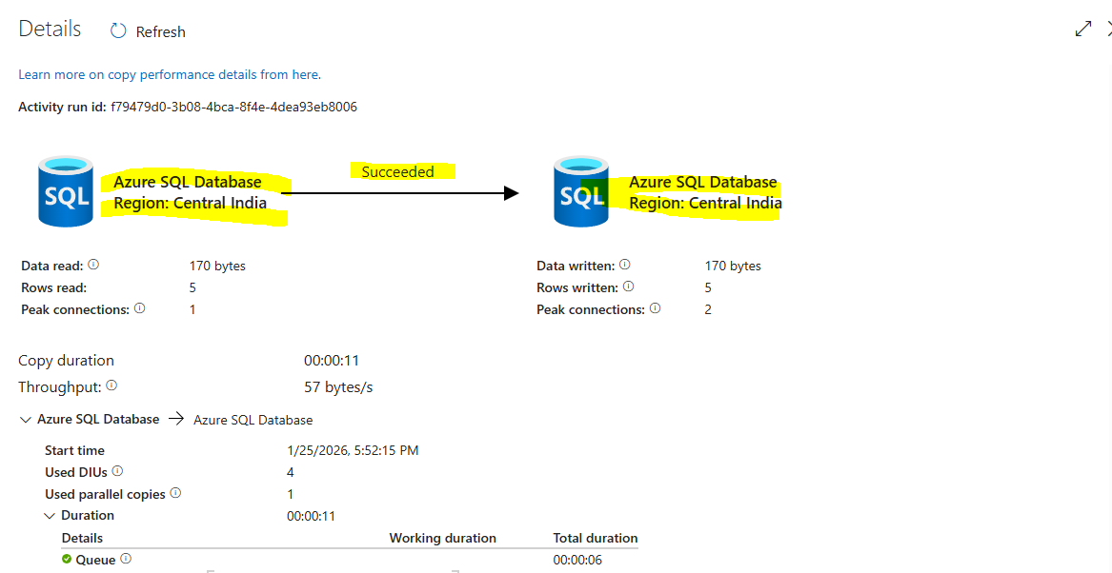

- In Azure Data Factory, create a pipeline to copy data from “SalesLT.Customer” Table to “retail.Customer” table in same Azure SQL DB. Ensure that everytime the destination table is empty before data is copied.
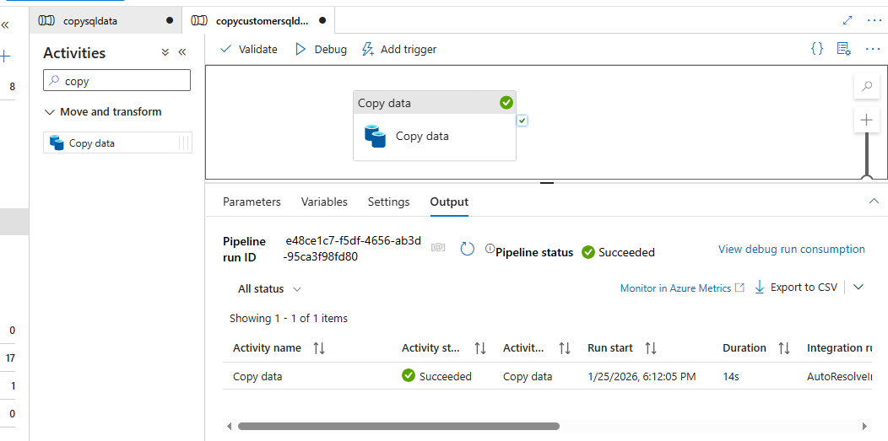

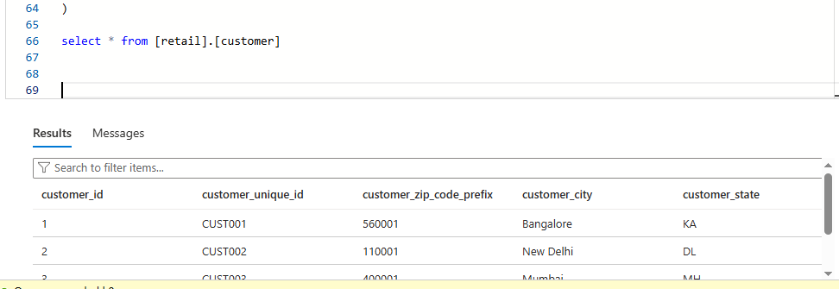

- In Azure Data Factory, create a pipeline to copy data of name=Bikes from “SalesLT.ProductCategory” Table to “retail.Bikes” table in same Azure SQL DB. 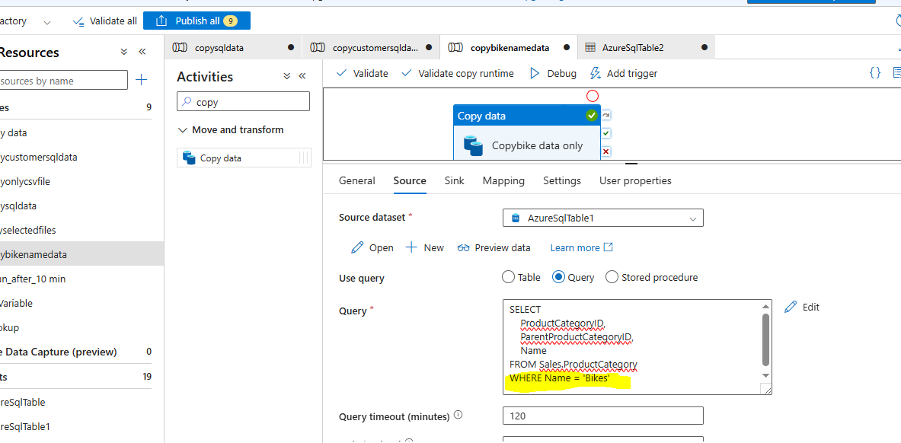
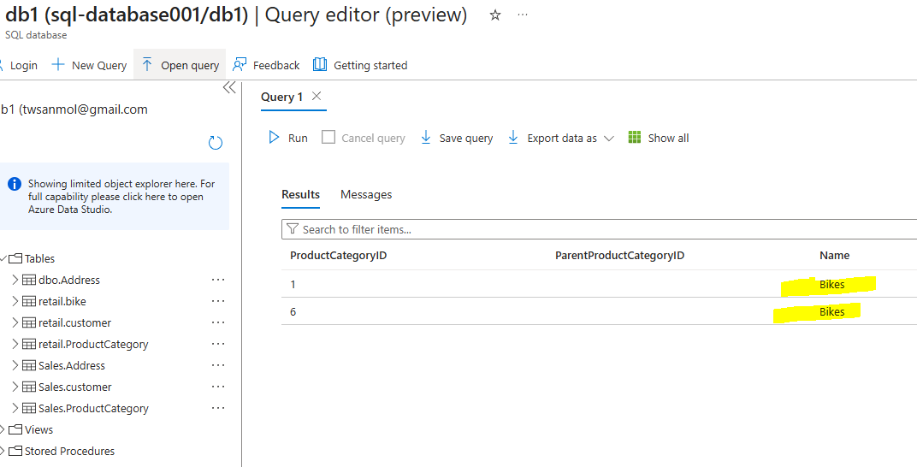

- In Azure Data factory copy the result of join between “SalesLT.SalesOrderDetails” and “SalesLT.SalesOrderHeader” to “retail.SalesOrderFullTable” 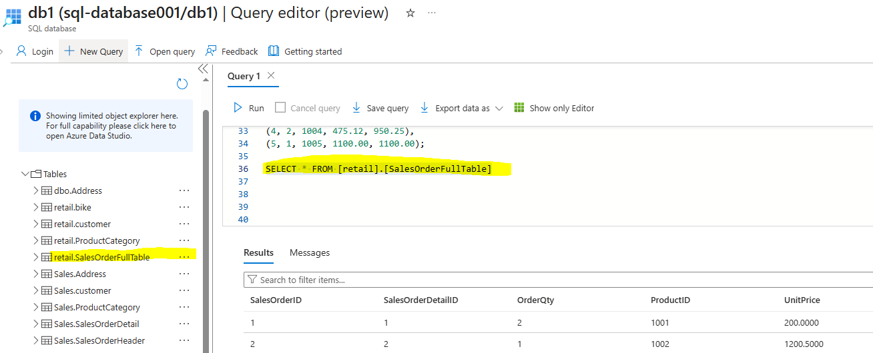 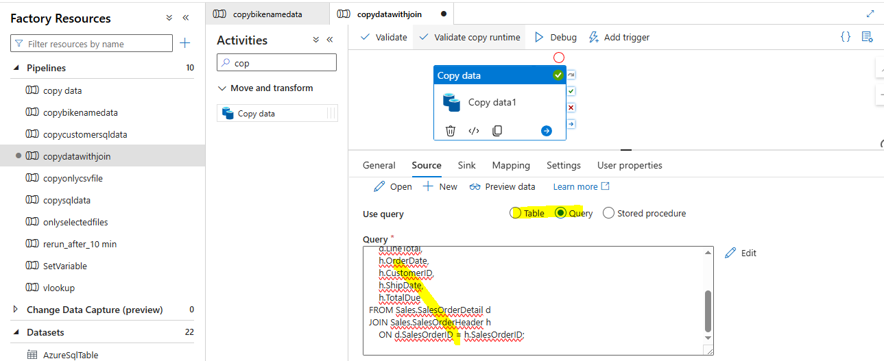 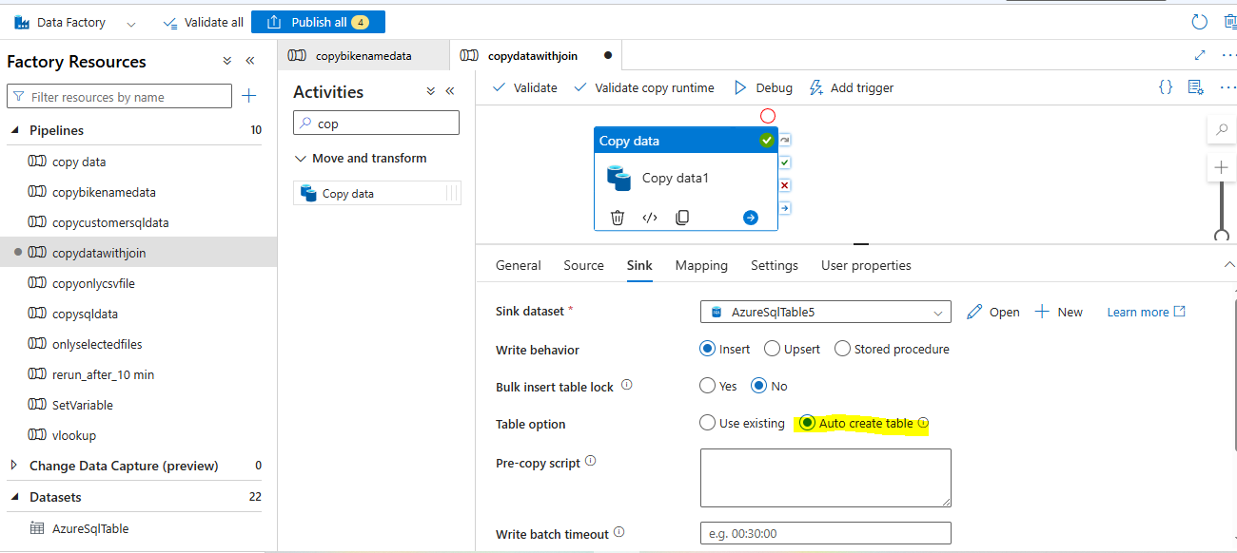

- Create a Procedure to insert the count of any 4 tables into a separate table and execute it in Azure Data Factory

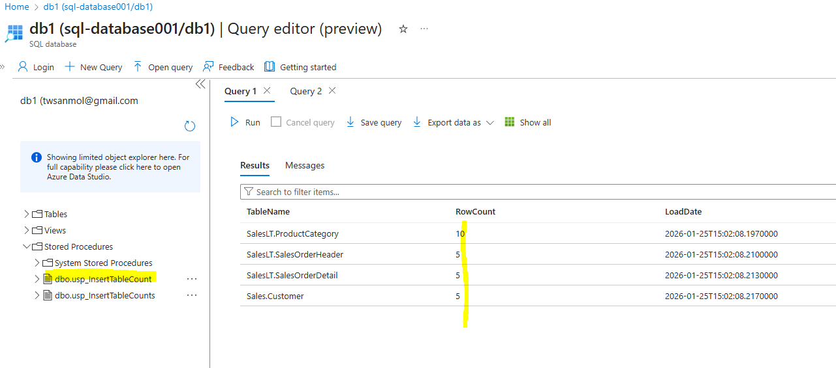
- Copy the data of “SalesLT.ProductModel” into “ProductModel.csv” into ADLS [Attach screenshot]. Make sure data is separated by ‘|’ 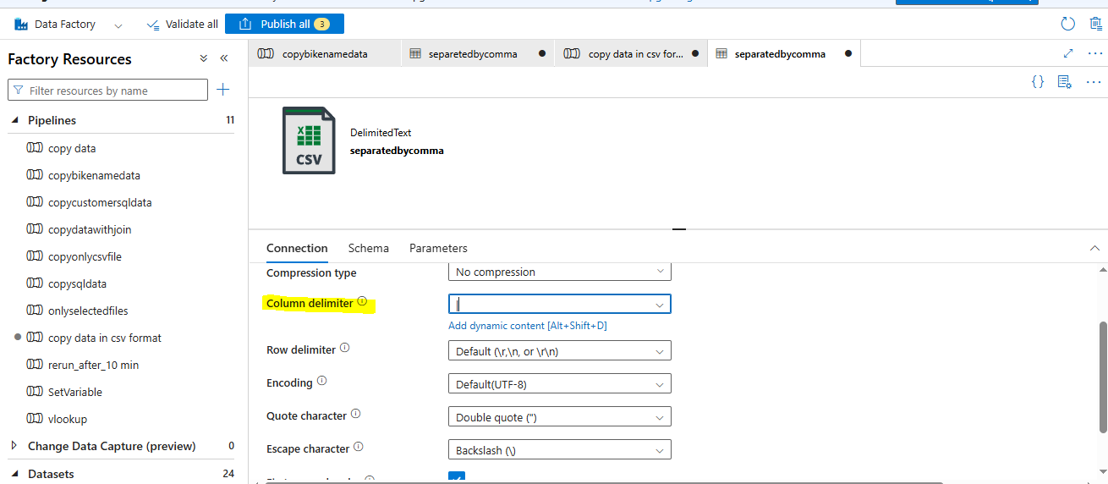 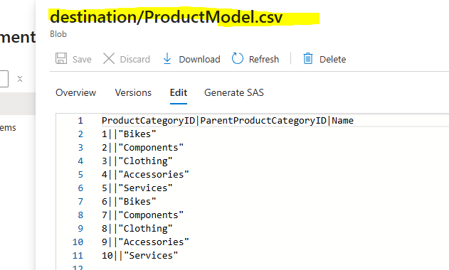

- Copy the data of “SalesLT.SalesOrderDetail” into “SalesOrderDetail.parquet” into ADLS
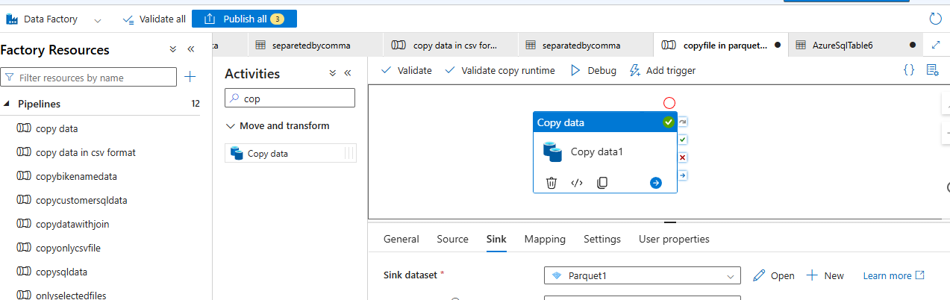
- In Azure Data Factory copied data from github to source or destination folder in container.
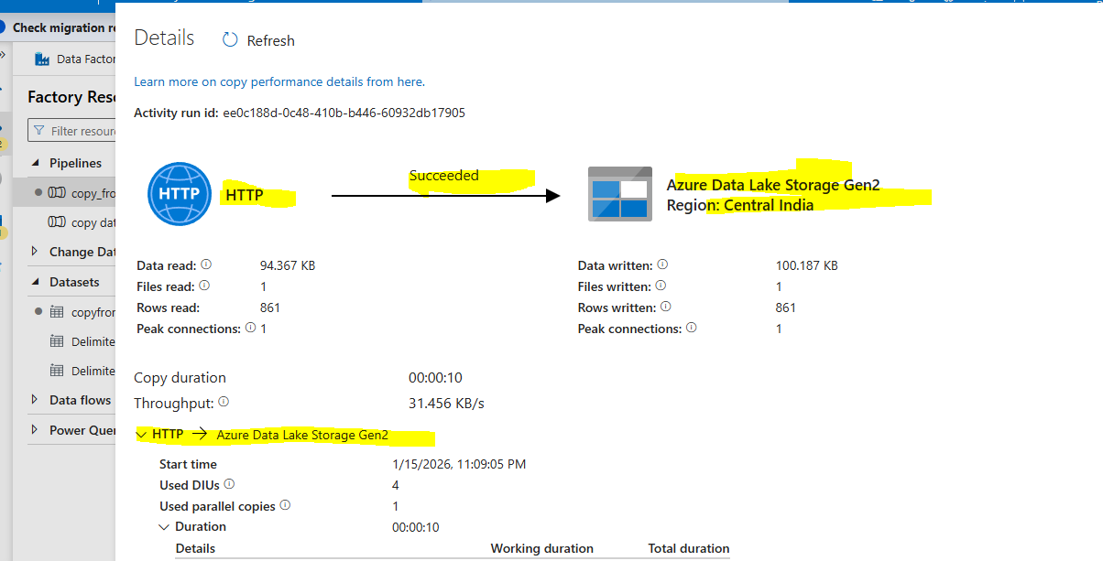
- Generating metadata of all files available in folders.
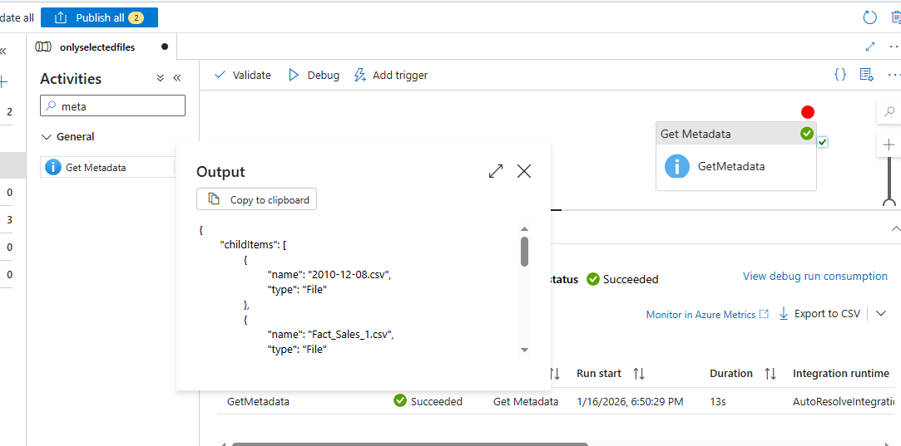

- Perform copy activity only for selected files through available all files in folders.
I have used activity are (Get metadata, foreach, if condition, copy activity through parameterized variable)
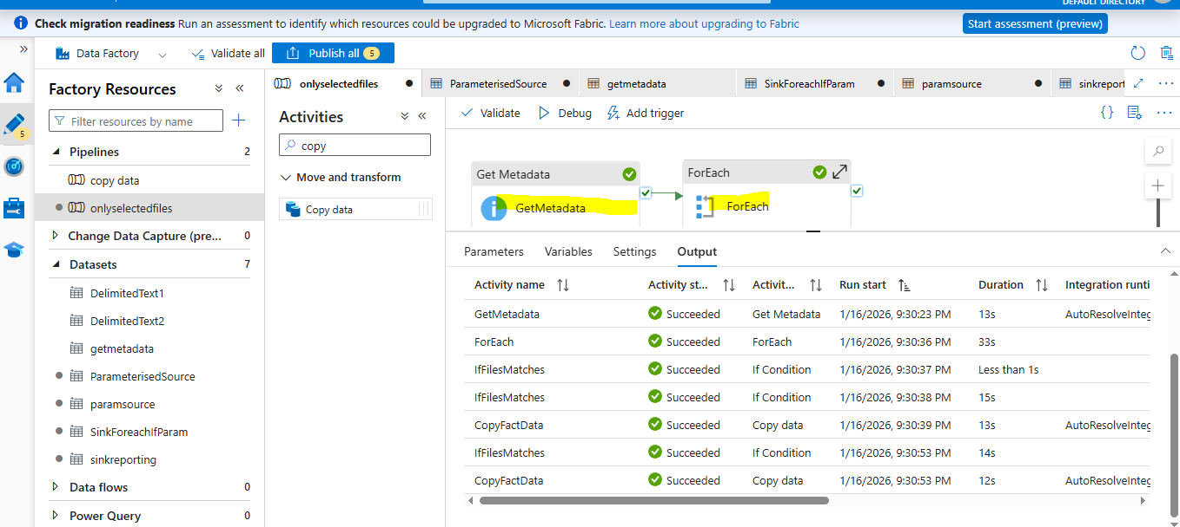

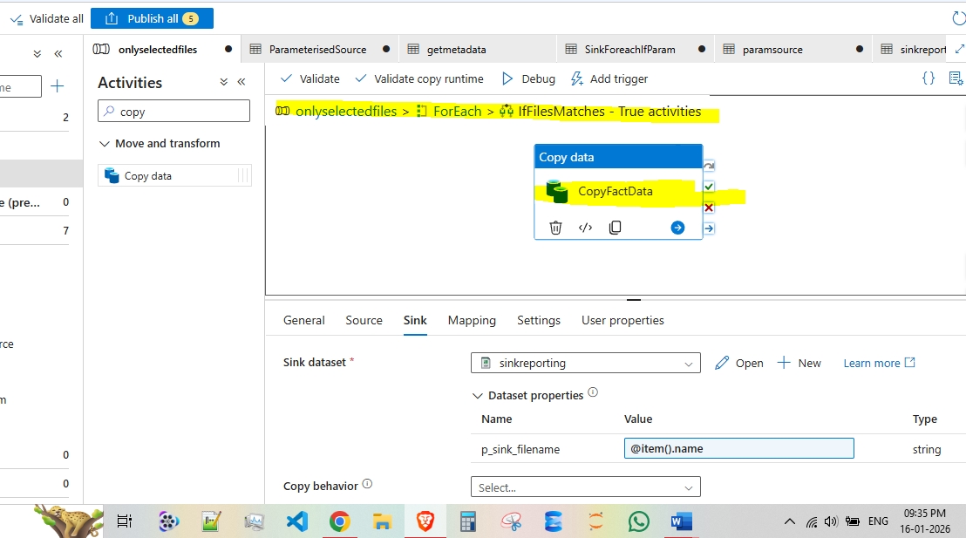

- Applied datafow for transformation done (filter,groupby, select column, sink, and spilt,derived column)

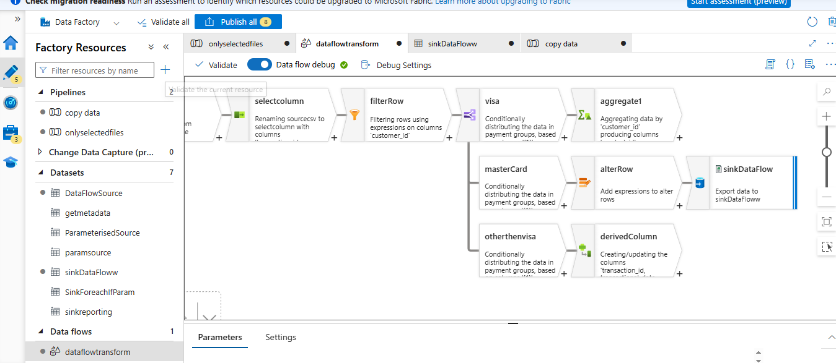
- Created a { SetVaribale } to store filename in arrays.
